C I N T R A F O R
Working Paper 75
Changing Export Trends and the Health of the Pacific Northwest Forest Sector
Bruce Lippke, Rose Braden, Scott Marshall. 2000
Executive Summary
The Pacific Northwest (PNW) forest sector is strategically linked to Pacific Rim markets, as it has been at a competitive disadvantage with the US South and interior Canada in delivering wood products to the population dense eastern and southern US markets. Deep-water port access to Asia however, has provided the PNW with a comparative advantage in serving what was until recently, the region with the world's highest sustained growth. The Asian financial crisis, which began in 1997, substantially reduced US exports to Asia, and has compounded the negative impacts of the harvest restrictions intended to protect the habitat of endangered species, which began in 1990. Both the Asian financial crisis and the harvest constraints are forcing long-term structural changes. Understanding these changes is important to maintaining the economic and biological health of the forest sector.
The Impact of the Asian Financial Crisis
US forest product exports to Japan, the largest export market, declined from $4.8 billion in 1996 to $2.8 billion in 1998 (-42%). And exports to South Korea, the third largest market for US wood products, declined from $963 million to $538 million (-52%). The only Asian market to avoid the crisis was China. US exports to China increased from $474 million in 1996 to $538 million in 1998 (+13%). While the Asian recession has forced substantial structural change in the PNW, such as permanent closure of many businesses, firms who survive are expected to increase their sales as the Asian economy rebounds.
The Impact of Harvest Restrictions
Since timber harvest restrictions were first implemented in 1990 to protect endangered species, harvest volumes have declined 30% in Washington, and over 40% in Oregon, from what were thought to be sustainable harvest levels. Lower harvest volumes resulted in substantial losses to logging and lumber processors and raised the cost of wood for secondary processors, reducing their competitiveness. Prior to the Asian crisis, the higher prices resulting from the reduced harvests mitigated some of the economic losses to timber producers, but they also motivated investments and increasing production rates by suppliers of wood from around the world. With the Asian crisis ending the period of tight markets, the second round of long-term structural adjustments to restore cost competitiveness at reduced harvest levels is now beginning.
The effects of these two issues on business income, exports, employment and forest health in the PNW are ongoing topics of analysis. The summary below is based on the report: Changing Export Trends and the Health of the Pacific Northwest Forest Sector, (CINTRAFOR WP75) which examines the data on changing export trends, supply and demand shifts and competitiveness, as policies are being implemented to promote the protection of endangered species.
Secondary Wood Products
Secondary wood product exports (doors, windows, joinery, moldings, furniture, cabinets, prefabricated components and prefabricated housing) increased to $320 million by 1996, a gain of over 100% in four years, largely driven by the Japanese government beginning to deregulate their home construction market. These gains were small in comparison to $3 billion in primary product exports, but they provide evidence of growing export opportunities. As shown in figure 1, while secondary product exports continued to increase as the PNW began to supply Japan's housing market, by 1997-1998 exports declined substantially. As the anticipated economic recovery in Japan and Asia stimulates consumer demand and deregulation continues to open these markets, however, market penetration should increase from current levels of about 1% of their market to levels more comparable with primary products (10-20%), which could sustain a strong recovery over many years.
Figure 1. Secondary exports from the Pacific Northwest to all destinations, 1989-1998
(US Department of Commerce 1999).
While secondary exports to Japan have increased overall, the PNW’s share of the Japanese market declined 23% as Canadian producers' share increased. Higher regional wood costs, fluctuating exchange rates, and higher levels of support to the forest sector provided by the Canadian government and forest products industry have helped Canadian producers catch up to the PNW and become a formidable competitor.
Revenue from secondary manufacturing in Washington State (inflation adjusted) has grown at nearly 3% per year, with a substantial portion of that growth due to increasing exports. While revenue growth has been constant, it has also been constrained by the harvest reductions and the higher cost of wood. Revenue from secondary manufacturing appears to have fallen below potential by as much as 15%. Even so, the sector has not been nearly as severely constrained as the primary processing sector. While exports could potentially increase by several billion dollars with only modest penetration of the Asian markets, declining competitiveness with Canada and other supplier regions may substantially reduce the PNW's growth potential.
There has also been a positive long-term trend in secondary processing productivity as the sector has improved productivity by almost 3% per year. This has resulted in much smaller increases in employment compared to production. Growth has also largely been located in communities close to metropolitan corridors and has not been of much help in offsetting the primary job losses in rural communities. Secondary wood product manufacturers generally have lower capital intensity than other wood or paper processors and their efficiency improvements reflect increased capital investments.
Primary Wood Products
Primary product export volumes also declined significantly as a consequence of harvest constraints. Prices for raw materials and finished goods increased as available volume decreased, which offset some of the losses in revenue for a few years. High timber prices allowed companies to harvest higher cost timber stands, requiring more workers, which reduced employment losses in rural timber dependent areas. These offsets may be short lived however, as timber prices declined substantially in 1997-98 with the Asian crisis, forcing another round of structural changes.
Lumber production did not decline nearly as much in Washington State as in Oregon, because substantial volumes of log exports were diverted from Washington ports to local mills, which almost offset the decline in local harvest. While the decline in log and lumber export revenues has been substantial (almost $2 billion), very strong demand from the US housing market has helped maintain high domestic lumber prices. Nevertheless, lumber margins in the 1990s have generally been below the cash flow levels needed to sustain capacity, resulting in more mill shutdowns and lowering the base of installed capacity. Logging and processing costs have increased by almost 20% relative to the US south. This cost disparity provides a direct measure of declining competitiveness and the need for additional restructuring.
Much of the decline in log exports is linked to worldwide restructuring followed higher log prices during the early 1990s. Export premiums once paid for hemlock logs may never be restored as the market has shifted to other suppliers such as Russia, Europe, New Zealand and Chile. Even spruce and fir export prices may not be fully restored by economic recovery in Asia, as the emphasis on pre-cut construction has shifted to more stable wood, such as dried lumber and engineered products.
The countervailing duty and quota agreement between the US and Canada has also affected US competitiveness in international markets. The agreement limits the amount of lumber Canada can export to the US duty free. While this quota provides protection for US lumber manufacturers, it forces Canadian producers to sell excess supply at lower prices to offshore markets, taking away the transportation and quality advantage the PNW once held. As Canada's domestic lumber prices have dropped, Canadian producers exported more lumber and secondary products to the Pacific Rim. The quota limitation on Canadian lumber to the US accelerated the shift from US log exports to lumber exports from Canada and Europe as Japanese buyers saw high US log and lumber prices relative to other suppliers. When US markets ultimately weaken, PNW log and lumber producers will feel the full effects of this loss in competitiveness in the Asian markets they once dominated. The US market share of logs and lumber in Japan has declined from 56% in 1989 to 31% in 1998, a 25% decline, as Europe gained share by 11%, Canada by 7%, and other suppliers by 7%.
Pulp and Paper
Unlike the solid wood sector; there is no demonstrated improvement in employee wages per dollar of sales for the pulp and paper producers. Rising wage costs, especially following harvest constraints, suggest facilities are operating at lower efficiency levels since supply has declined. Since pulp and paper mill capital costs have more than doubled over the last two decades (as mills invested in technologies to reduce effluent), there has been an increase in capital costs, wages, and wood costs, which has reduced profitability and competitiveness. Greater use of recollected waste fiber has not offset rising costs. Washington State’s pulp and paper facilities have become high cost producers in the global market, resulting in several closures and strategic shifts to other regions with lower cost fiber resources, such as South America.
Business Income and Employment
Overall, business income in the forest sector did not decline as much as harvest rates, since prices partially offset the negative impacts of the early harvest declines. Changes over a five-year period before the harvest declines (1986-1991) and after (1992-1997) show that Washington’s timber harvest volume declined 31%, but logging employment declined only 22%. Both logging and processing costs have increased relative to the US South, compromising Washington's ability to compete. If production efficiency improved, Washington State could lose another 2,000 rural logging jobs.
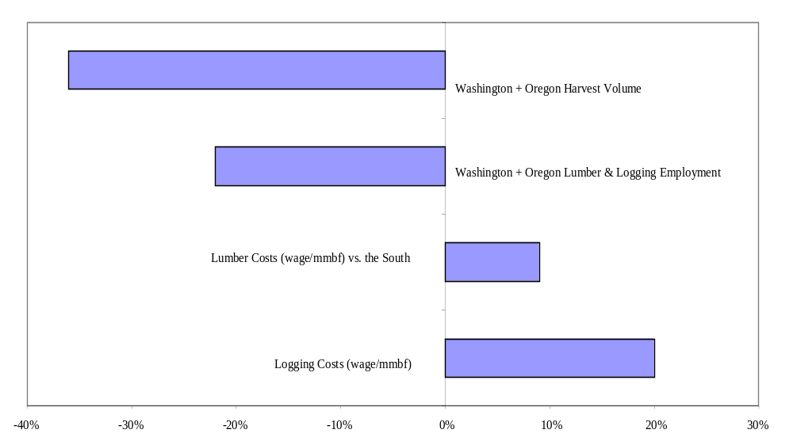Figure 2. PNW change from 1986-1991 in harvest, employment, and costs
(CINTRAFOR 1999).
Approximately 12,600 primary processing jobs in Washington and Oregon, and an equal number of indirect rural jobs, have been lost since 1992. Unemployment rates are still 6% higher in timber- dependent communities than in urban communities. New timber harvest restrictions to protect salmon populations, combined with industry restructuring to make PNW production costs competitive with other regions will compound already high employment losses and regional disparity. The 66% increase in disparity between urban and timber rural county incomes experienced by 1997 will almost certainly worsen before adjustments to timber harvest reductions have been absorbed.
While the PNW has experienced losses in revenue, employment, and market share, the region still maintains a fundamental long-term comparative advantage in growing timber and accessing international markets. The increase in income from both secondary manufacturing, improvement in product yields, and higher valued exports, which collectively characterized the growth in the sector before the harvest constraints, should be restored once this lagging adjustment process to changing markets and policies is complete. Unfortunately, the evidence suggests that the structural adjustments to meet new regulations and restore competitiveness are not yet complete.
Increased Old-Forest Habitat for Endangered Species
While recent federal and state regulations have reversed the trend of declining old forest habitat, since the regulations rely on reserves to restore critical habitat, the projected habitat improvements are both slow and costly. Simulations for the westside of Washington show late seral structures of importance to endangered species increasing from 11% of the acres to 18% by the 5th decade and 33% by the 10th decade. Reserves age slowly without the benefit of periodic fires and other disturbances that in pre-European times contributed to the creation of diverse forest structures. Reserve stands that are now too dense for good habitat will remain in this condition for many decades. Simulations of active management strategies to restore habitat on at least some acres show more a more rapid restoration of old forest habitat conditions, obtained at a lower cost. More rapid deployment of new technologies in rural areas affecting timber production, forest protection, and habitat restoration will be critical to future environmental progress as well as the impact on rural communities. To provide better insights on how to increase the rate of environmental progress or reduce the negative economic consequences that have resulted from recent policies, Washington State could benefit from a more systematic effort to assess environmental progress and economic sustainability.
Other Perspectives
While taxes remain a concern to forest landowners, changes in regulatory impacts in the last decade have had much greater impacts than taxes. Concerns over accelerated land conversions and sales by small non-industrial forest owners have increased. Harvest rates for non-industrial private forest owners doubled in the 1990s, reaching unsustainable rates. While the several-year period of high prices prior to the Asian crisis provided an opportunity to liquidate mature timber, it also offset the landowner’s losses resulting from environmental regulations. With the expectation of lower timber prices and higher regulatory costs, the motivation for small landowners to manage the land for timber rather than sell to larger owners or to real estate developers will diminish.

